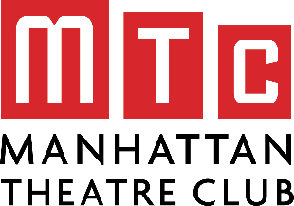
Building Character
Creating an Original Monologue

Your Name:
Today’s Date:
Teacher/Class Period:

Character’s Name:

Prompt ideas to help you get started:

- There’s something I need to say to you.
- You have no idea…
- Why did you…?
- For the last time…

Before you get started make sure you can answer the following questions:

- Who is your character speaking to? What is their relationship to that person (or people)?
- Where does this take place? What is the setting?
- Why is your character talking? What do they need?

Type your monologue here:

